|  |
| --- |
|  |
|  |

|  |  |  |  |  |  |
| --- | --- | --- | --- | --- | --- |
| REVISION HISTORY | | | | | |
| Ver. | Description of Change | Author | Date | Approved | |
| Name | Effective Date |
| 1.0 | Initial status | Olga_Hilko | 19-NOV-2017 |  |  |

Contents

1. CREATE Storage Objects 3

2. Generate Test Data in Storage Layers 3

2.1. Base scenario 3

2.2. Results 4

2.3. Db Scheme 7

2.4. Recall of the main ETL 8

2.5. Results of the recall 8

2.6. Recall data errors 9

2.7. Data correction 10

3. SQL*Plus 11

3.1. Linux connection 11

3.2. Windows connection 12

3.3. Execution plan 13

3.4. Save to file 13

3.5. Script 15

# CREATE Storage Objects

Uses were created and granted. External tables where created

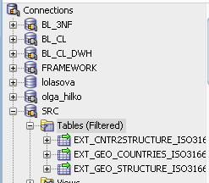

Scripts for creating users, their grants and tables (are finished with *DDL.sql) are in git.

# Generate Test Data in Storage Layers

## Base scenario

Here is the code, which orchestras the ETL.

**connect FRAMEWORK/123456;**

show user;

@FRAMEWORK_pkg.sql

@FRAMEWORK_grant.sql

**connect SRC/123456;**

show user;

@SRC_DDL.sql

@SRC_grant.sql

commit;

**connect BL_CL/123456;**

show user;

@BL_CL_DDL.sql

**connect BL_3NF/123456;**

show user;

@BL_3NF_DDL.sql

@BL_3NF_grant.sql

**connect BL_CL/123456;**

show user;

--SRC to WRK pkg

@BL_CL_PKG1.sql

--WRK to CL pkg

@BL_CL_PKG2.sql

-- CL to 3NF pkg

@BL_CL_PKG3.sql

**-- the main ETL**

connect BL_CL/123456;

show user;

@BL_CL_call_pkg.sql

## Results

Connected

**USER is "FRAMEWORK"**

Package PKG_UTL_DROP compiled

Package body PKG_UTL_DROP compiled

Package PKG_UTL_GRANTS_MGMT compiled

Package body PKG_UTL_GRANTS_MGMT compiled

Grant succeeded.

Grant succeeded.

Connected

**USER is "SRC"**

**Directory EXT_TABLES created.**

PL/SQL procedure successfully completed.

**Table EXT_GEO_COUNTRIES_ISO3166 created.**

PL/SQL procedure successfully completed.

**Table EXT_GEO_STRUCTURE_ISO3166 created.**

PL/SQL procedure successfully completed.

**Table EXT_CNTR2STRUCTURE_ISO3166 created.**

PL/SQL procedure successfully completed.

Grant succeeded.

PL/SQL procedure successfully completed.

PL/SQL procedure successfully completed.

PL/SQL procedure successfully completed.

Commit complete.

Connected

**USER is "BL_CL"**

PL/SQL procedure successfully completed.

**Table WRK_GEO_COUNTRIES_ISO3166 created.**

PL/SQL procedure successfully completed.

**Table WRK_GEO_STRUCTURE_ISO3166 created.**

PL/SQL procedure successfully completed.

**Table WRK_CNTR2STRUCTURE_ISO3166 created.**

PL/SQL procedure successfully completed.

**Table CL_CONTINENTS created.**

PL/SQL procedure successfully completed.

**Table CL_REGIONS created.**

PL/SQL procedure successfully completed.

**Table CL_COUNTRIES created.**

PL/SQL procedure successfully completed.

PL/SQL procedure successfully completed.

PL/SQL procedure successfully completed.

PL/SQL procedure successfully completed.

PL/SQL procedure successfully completed.

PL/SQL procedure successfully completed.

Connected

**USER is "BL_3NF"**

PL/SQL procedure successfully completed.

**Table CONTINENTS created.**

PL/SQL procedure successfully completed.

**Table REGIONS created.**

PL/SQL procedure successfully completed.

**Table COUNTRIES created.**

PL/SQL procedure successfully completed.

PL/SQL procedure successfully completed.

PL/SQL procedure successfully completed.

PL/SQL procedure successfully completed.

PL/SQL procedure successfully completed.

PL/SQL procedure successfully completed.

Connected

**USER is "BL_CL"**

Package PKG_SRC_TO_WRK compiled

Package body PKG_SRC_TO_WRK compiled

Package PKG_WKR_TO_CL compiled

Package body PKG_WKR_TO_CL compiled

Package PKG_CL_TO_3NF compiled

Package body PKG_CL_TO_3NF compiled

Connected

**USER is "BL_CL"**

PL/SQL procedure successfully completed.

Commit complete.

PL/SQL procedure successfully completed.

PL/SQL procedure successfully completed.

PL/SQL procedure successfully completed.

Commit complete.

PL/SQL procedure successfully completed.

**Lola: Loading into BL_3NF.Continents is successful**

PL/SQL procedure successfully completed.

**Lola: Loading into BL_3NF.Regions is successful**

PL/SQL procedure successfully completed.

**Lola: Unpasted rows in BL_3NF.Countries table:2 row(s)**

>>Query Run In:Query Result 1

Connection created by CONNECT script command disconnected

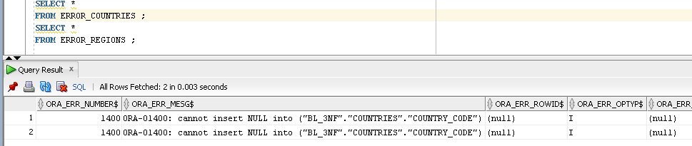

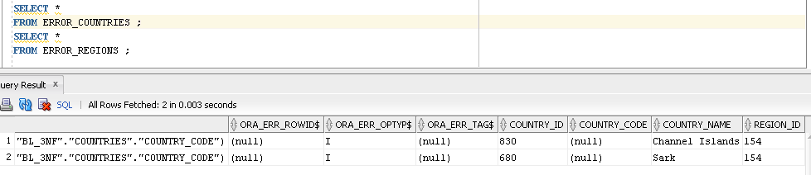

## Db Scheme

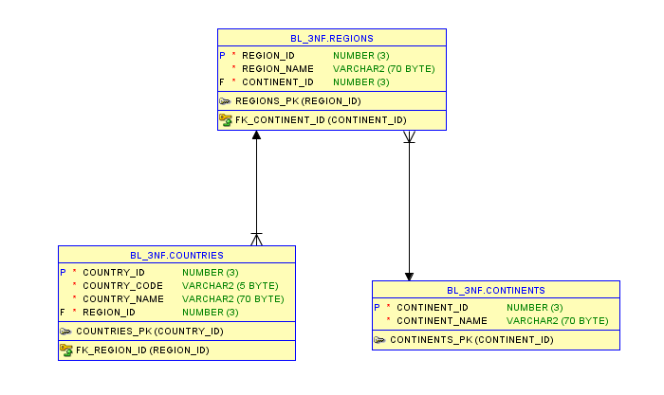

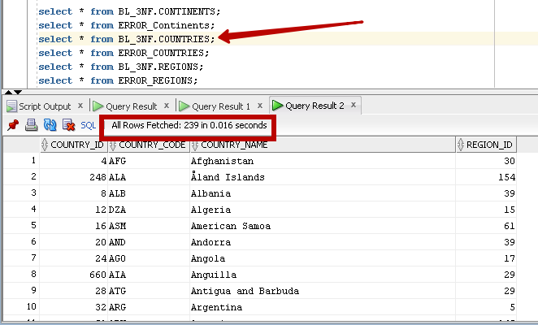

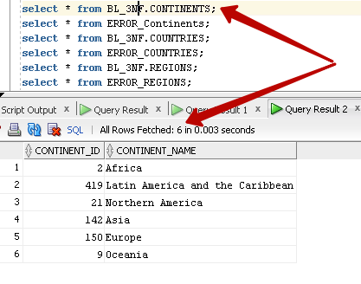

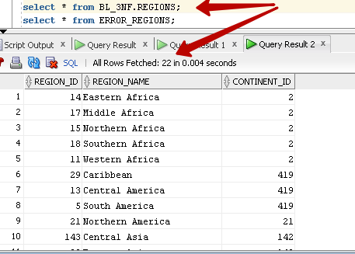

## Recall of the main ETL

connect BL_CL/123456;

show user;

@BL_CL_call_pkg.sql

## Results of the recall

Connected

USER is "BL_CL"

PL/SQL procedure successfully completed.

Commit complete.

PL/SQL procedure successfully completed.

PL/SQL procedure successfully completed.

PL/SQL procedure successfully completed.

Commit complete.

PL/SQL procedure successfully completed.

**Lola: Unpasted rows in BL_3NF.Continents table:6 row(s)**

PL/SQL procedure successfully completed.

**Lola: Unpasted rows in BL_3NF.Regions table:22 row(s)**

PL/SQL procedure successfully completed.

**Lola: Unpasted rows in BL_3NF.Countries table:241 row(s)**

Connection created by CONNECT script command disconnected

## Recall data errors

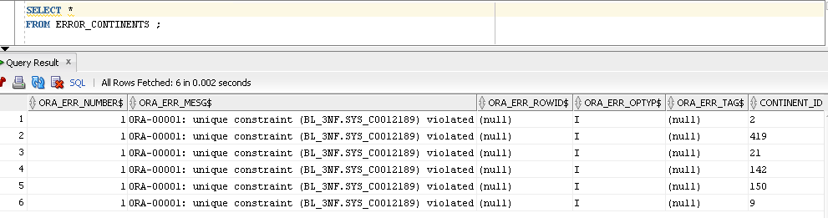

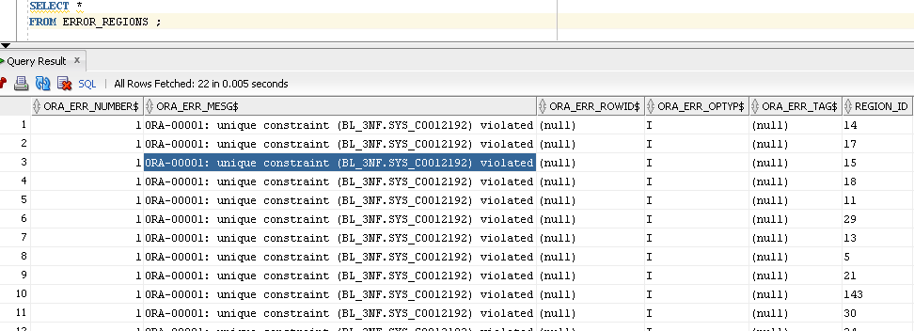

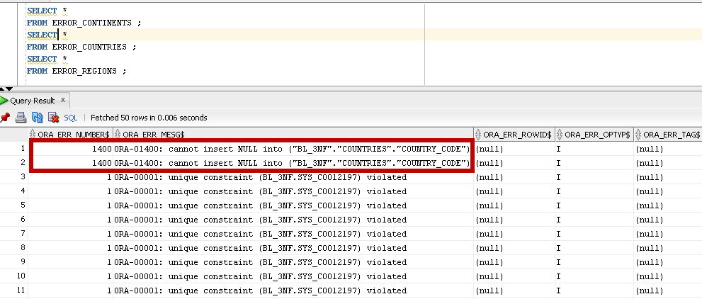

## Data correction

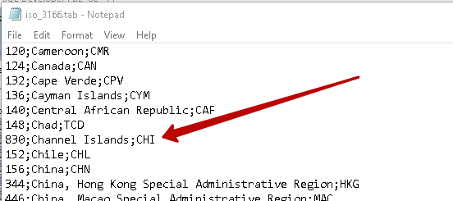

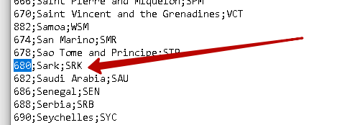

**Recalled code**

connect BL_CL/123456;

@BL_CL_PKG1.sql

@BL_CL_PKG2.sql

@BL_CL_PKG3.sql

@BL_CL_call_pkg.sql

**Now we have full data, only 2 rows were pasted.**

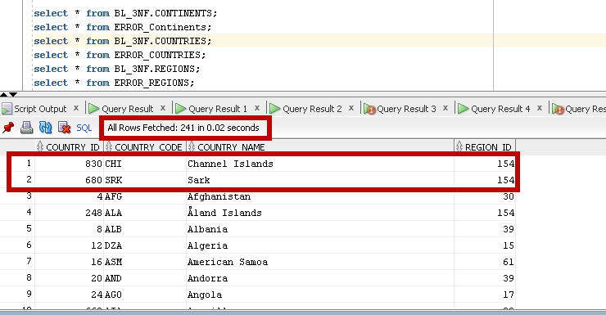

# SQL*Plus

## Linux connection

Connect to a database via SQL*Plus client:

We have probles in linux

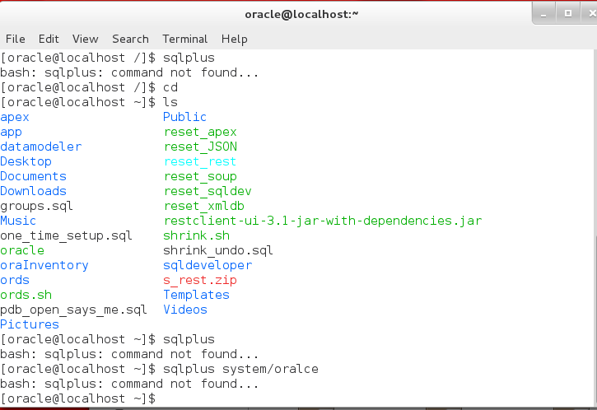

## Windows connection

Connect to sqlplus from Windows command line (connection is to the 11g xe version)

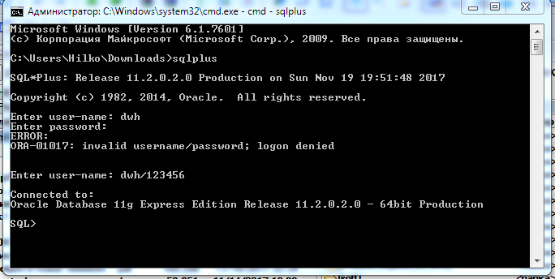

first select

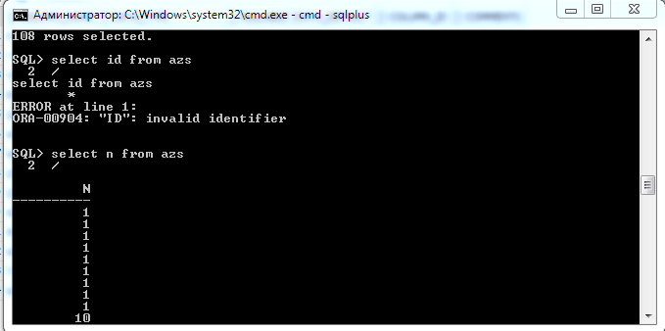

## Execution plan

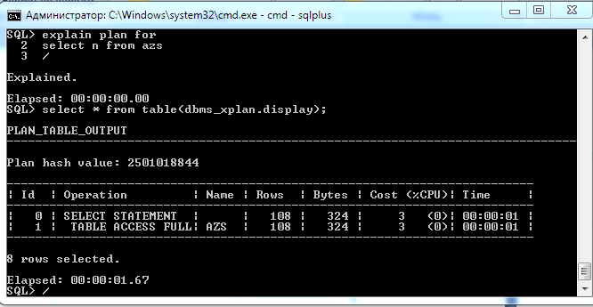

## Save to file

create file

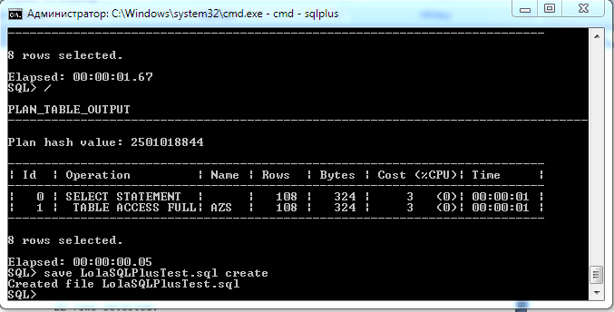

find the file

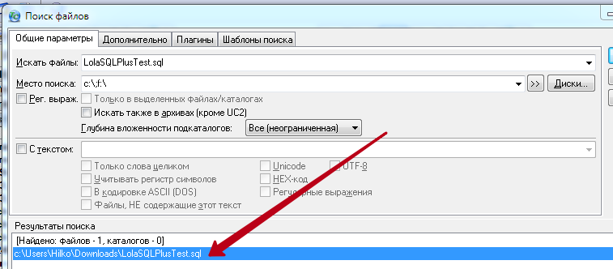

view the file

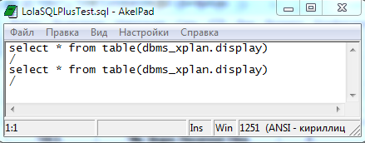

save sql results to file

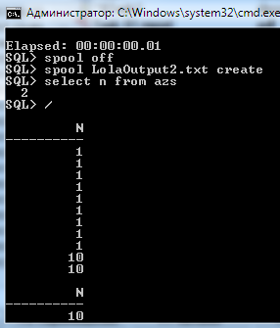

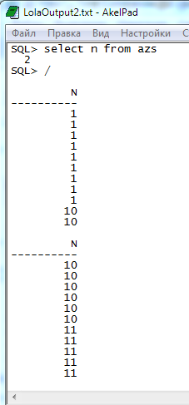

## Script

run script file

